

Logan House Loop Road trail S.N.

This information is not to be used for navigation. Information contained herein is provided as a courtesy and is meant to be used as a starting point in comparing trails and planning an adventure. You and you alone can ensure a safe adventure by developing skills, building redundancy into your planning along with contingences for ever changing trail and weather conditions. You should always be prepared, check with the local agency having jurisdiction and travel with experienced people.

State: Nevada

County: Douglas County

Trail Name: Logan House Loop trail S.N.

Trail also known as: 14n33

Trailhead Latitude: 39.03719N

Trailhead Longitude: 119.88405W

Season: Summer and Fall (check before you go)

Scenic Rating: 7

Technical Rating: 2

Distance miles: 8.6 Point to Point

Travel Time hours: 2 hours one way

Area miles: N/A

Elevation start of trail: 8,436 ft.

Elevation end of trail: 8671 ft.

Maximum Elevation: 7,705 ft.

Grade :

Accent: 880 ft.

Decent: 1,608 ft.

The information above was complied by using GPS aided maps and actual driving experiences.

Douglas County Sheriff (775) 783-6466

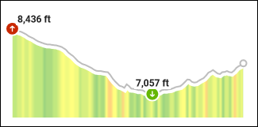Logan House Loop Road trail

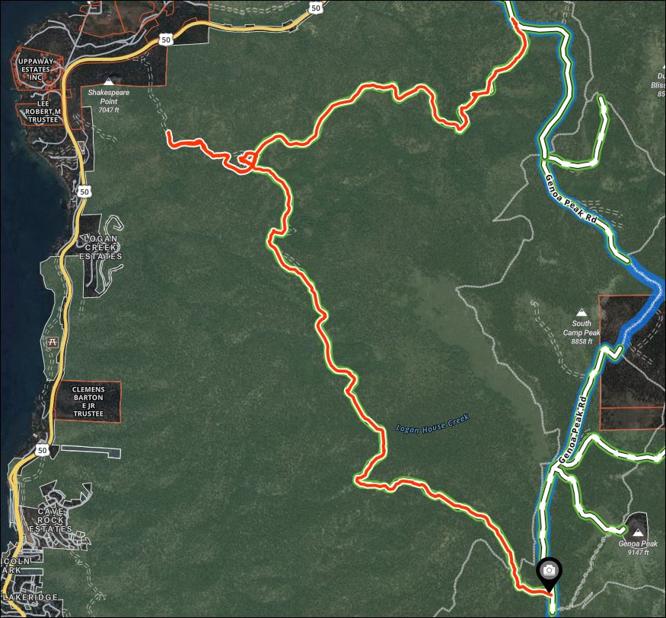

State: Nevada

County: Douglas County

Trail Name: Logan House Loop Road trail

Trail also known as: 14n33

Trailhead Latitude: 39.03719N

Trailhead Longitude: 119.88405W

**Douglas County Sheriff (775) 783-6466**